|  |
| --- |
| **A**  **PROJECT REPORT ON** |
|  |
|  |
| Vehicle Management System |
| SUBMITTED IN  PARTIAL FULFILLMENT OF  **DIPLOMA IN ADVANCED COMPUTING (PG-DAC)** |
|  |
|  |
|  |
|  |
|  |
|  |
|  |
| **BY**  **Abhijeet**  **Sanket**  **Tushar**  **Yash Jawalkar** |
|  |
|  |
| **UNDER THE GUIDENCE OF**  **Shubham Borle** |
|  |
|  |
|  |
| **AT**  **SUNBEAM INSTITUTE OF INFORMATION TECHNOLOGY,**  **PUNE** |

|  |  |  |  |
| --- | --- | --- | --- |
| **SUNBEAM INSTITUTE OF INFORMATION TECHNOLOGY,**  **PUNE.** | | | |
|  | | | |
|  | | | |
|  | | | |
|  | | | |
| **CERTIFICATE** | | | |
|  | | | |
| This is to certify that the project | | | |
|  | | | |
| Vehicle Management System | | | |
|  | | | |
| Has been submitted by | | | |
|  | | | |
| **Abhijeet**  **Sanket**  **Tushar**  **Yash Jawalkar** | | | |
|  | | | |
|  | | | |
| In partial fulfillment of the requirement for the Course of **PG Diploma in Advanced Computing (PG-DAC Sep 2023)** as prescribed by The **CDAC** ACTS, PUNE. | | | |
|  | | | |
|  | | | |
| Place: Pune | | | Date: 22-FEB-2024 |
|  | | | |
|  | | | |
|  | | | **Rajiv Kamune** |
|  | | | **Project Guide** |
|  |

**ACKNOWLEDGEMENT**

I would like to express my special thanks of gratitude to my teacher Shubham Borle as well as our Director Nitin Khudale who gave me the golden opportunity to do this wonderful project on the topic User Analytics, which also helped me in doing a lot of Research and I came to know about so many new things I am really thankful to them.

Abhijeet Tripathi

**ABSTRACT**

Multi-Platform Application that will track user’s daily life stats and let the user see how well he/she doing. Application will get data from sensor and user can also put data manually all this data is supposed to be synced with server and stored in data base. A website of same application will allow user to see details in very informatic manner

|  |  |  |
| --- | --- | --- |
|  | **INTRODUCTION** | 1 |
|  | 1.1 Introduction | 2 |
|  | **Product Overview and Summary** |  |
|  | 2.1 Purpose |  |
|  | 2.2 Scope |  |
|  | 2.3 User Classes and Characteristics |  |
|  | 2.4 Design and Implementation Constraints |  |
|  | **REQUIREMENTS** |  |
|  | 3.1 Functional Requirements |  |
|  | 3.1.1 Use case for Administrator. |  |
|  | 3.1.2 Use case for User. |  |
|  | 3.2 Non - Functional Requirements |  |
|  | 3.2.1 Usability Requirement |  |
|  | 3.2.2 Performance Requirement |  |
|  | 3.2.3 Reliability Requirement |  |
|  | 3.2.4 Portability Requirement |  |
|  | 3.2.5 Security Techniques |  |
|  | **PROJECT DESIGN** |  |
|  | 4.1 Data Model |  |
|  | 4.1.1 Database Design |  |
|  | 4.2 Process Model |  |
|  | 4.2.1 Functional Decomposition Diagram |  |
|  | 4.2.2 Data Flow Diagram (DFD) |  |
|  | **PROJECT RELATED STATISTICS** |  |
|  | **CONCLUSION** |  |

**INDEX**

**LIST OF TABLES**

|  |  |  |
| --- | --- | --- |
| **Section** | **Table Title** | **Page** |
| **Fig 3** | **Complete Database** |  |
|  |  |  |
|  |  |  |
|  |  |  |
|  |  |  |
|  |  |  |

**LIST OF FIGURES**

|  |  |  |
| --- | --- | --- |
| **Section** | **Figure Title** | **Page** |
| **Fig 1-2** | **User & Admin Use Case Diagram** |  |
| **Fig 3** | **Data Flow Diagram** |  |
| **Fig 4 -9** | **Dashboard Screen Shots** |  |
| **Fig 10-13** | **Mobile Application Screen Shots** |  |
|  |  |  |
|  |  |  |
|  |  |  |
|  |  |  |
|  |  |  |
|  |  |  |
|  |  |  |
|  |  |  |

**INTRODUCTION**

Since the emergence and popularization of smartphones, many mobile applications that track and record data about their users have been created. The classic example of this is the pedometer which utilizes the mobile device’s built-in accelerometer to track the number of steps the user takes each day. Applications in this category, that track and record health or activity data about their users, are typically called Wellness or Fitness Apps. These Wellness Apps are designed to assist the user in pursuing a healthy lifestyle by encouraging them to perform positive activities, and improve lifestyle choices. Factors that are typically targeted by such applications include exercise, sleep, and diet. Understanding the nature of this relationship is crucial when designing a Wellness App. Applications like this have the potential to motivate its users into maintaining a cycle of positive lifestyle decisions and/or breaking a cycle of negative lifestyle decisions. Diet, exercise and sleep can influence several physiological pathways associated with depression and a bidirectional relationship likely exists between depression and these lifestyle factors, thereby creating a potentially increasing cycle of influence.

**The goal of this project:** The purpose of this project was to create a wellness application for the Android platform capable of tracking, recording, and displaying data relevant to a user’s sleep, activity, and mood habits. This application also enables individuals to become aware of deficiencies in their everyday habits and will hopefully encourage the user to self-regulate towards improvement. The overall goal is to show the user his or her daily habits and help them to make choices that will result in a healthier lifestyle, and therefore, a happier life. This document will comprehensively describe such an application’s research, design, testing, and development.

**Product Overview and Summary**

**| Purpose:** Through research of similar apps we found a number of features that seemed useful in our design. Simplistic Design: Overall, we found that the Moves app presented an extremely clean and simplistic layout that presented important information as soon as it was opened. We decided to model our app with this same mentality of keeping screens simplistic and present important data upfront

**| Scope**: Step Counting When a user has their phone in their pocket or attached to their body in some form, and they take a step, the phone will move in a distinct manner. By using the sensors in the phone, we hoped to develop an algorithm to track this movement, and, in turn, track a user’s steps. After some research, we found a simple step counting algorithm that tested the change in the phone’s position on the y-axis, and if this change in distance was greater than some user defined threshold, the algorithm would add a step (Michaud). After testing this algorithm for some time, we found that it was not as accurate as we had anticipated. We decided to adjust the algorithm to not only track the change in the y position of the phone, but to calculate the total change in distance of the x, y, and z coordinates. Unfortunately, this was not much more accurate in counting steps than our previous implementation so we began researching alternative methods for tracking exercise. We eventually came across the Google Fit API, which utilizes a phone’s various sensors to implement algorithms that record and store different sets of fitness data, including step counting. That data is sent to the Google Fit Service and is then available to the developer to use as he or she needs. There are several components to tracking fitness data using the Google Fit API.

**User Classes and Characteristics**: As based on multiple platforms there are multiple classes and their uses but most importantly application uses Model for user that encapsulates data fetched from server like steps calories etc

And both iOS and android platforms have their own implementation of Data persistence For Example Android Uses shared preference which contains a helper class to provide such functionality

Where as iOS uses user’s default which do not contain helper class can be accessed directly although

**| Design and Implementation Constraints**

**- User Interface**

In order to effectively incorporate each of the three focus areas of our application (sleep, food consumption) into the user interface without creating too much clutter, we opted to use a tabbed design. When the app is initially opened, the user is taken to the “main” or “home” tab.

**- Tab Design**: Relatively early in the development process, we came to the decision to separate each data tracked aspect (steps, sleep, and mood) into individual tabs within the app. After researching several different methods for implementing this type of multi-page app design, we came to the decision to use the ViewPager layout manager, an Android class that is “most often used in conjunction with Fragment, which is a convenient way to supply and manage the lifecycle of each page” (ViewPager). Each of the four tabs is implemented in its own class, and is a subclass of the Fragment class. In addition, the tabs share a single Android activity, which is the Android class that handles all user interaction with the app. The main activity of the application manages the tab layout and tells the application which tab view to display when a user selects a certain tab. The purpose of using fragments is to eliminate the need to create a new activity every time the user switches between tabs, thus increasing both the temporal and spatial efficiency of the application. Structurally, each fragment is comprised of two components. The first is an XML file that defines the visual layout of the fragment. The second is the logic of the fragment, which contains various functions defining certain actions to take at different times. Each time a certain fragment is switched to or away from, these functions are called in a particular order, all of which make up what is called the fragment’s “lifecycle”. For example, when a particular fragment is displayed on the screen, the function onCreateView() is called, which is generally where most of the initialization process occurs

**Functional Requirements**

**| Use Case for User**:

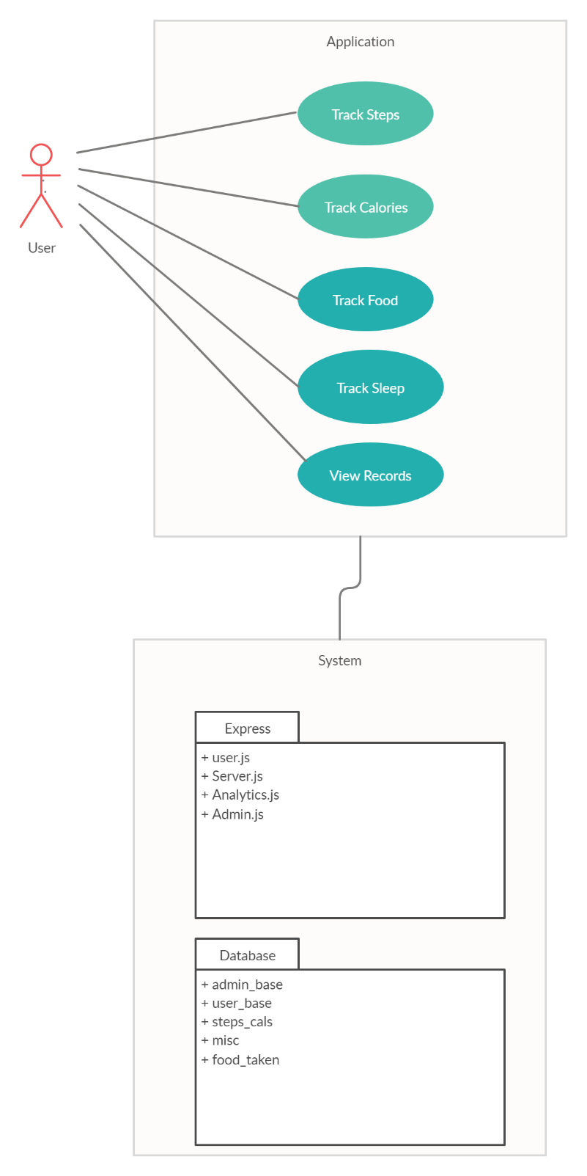

Fig. 1

**| Use Case for Admin**:

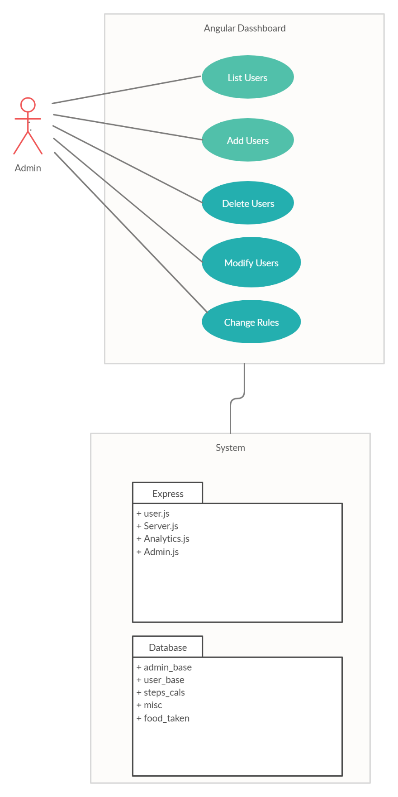

Fig. 2

**Non - Functional Requirements**

**Usability Requirement:** Application should be easy to use and provide basic user interface that can be used without any tutorial.

Multiple views must be used for modularity in this concept, I will be referring to the ease of use of a mobile application. The aim of the use of the mobile application is to get some features and functionality and the application would be difficult to use without the usability being considered. Every application is expected to be effective, sophisticated, and satisfactory and the color and contrast should be intact and follow some other principles that are considered the standard to be followed by developers. The design of the application should be done in such a way that users of all abilities would be able to use the UI efficiently.

Also, those with different disabilities such as hearing impairment, low vision, or blindness should be able to engage themselves in using the apps. Users of all apps should be able to appreciate the color and contrast of the mobile applications. Developers should also take into consideration the sound implementation of the app, which is an alternative to the visual implementation. Unnecessary sounds should always be avoided and the sounds that interpret screen elements or content should be designed for a correct or almost correct efficiency.

**Data Model**

Database In order to effectively store the user’s step counting and sleep tracking history, we decided to use a SQL database, which is already built into the Android operating system. Because Google Fit integration automatically manages the step counting data, our database only has two tables, one for mood data and another for sleep data. The Database Schema for Sleep and Mood Data The first step in implementing the database was to create objects that could be used to store and retrieve information for each data type. More specifically, we created a sleep tracking class and a mood tracking class. Each class has two variables, as well as methods for setting and getting these variables. As seen in Figure 15, the sleep counting class contains a variable for the number of hours slept the night before, and the mood tracking class stores a number ranging from one to ten (where one represents the least happy, and ten represents the happiest). Each class also contains a variable representing the date at the time the data was stored. We then use these classes to periodically store the numerical data. For example, when the application detects that the user has woken up in the morning, it will calculate the number of hours that he or she has slept. It then creates an instance of the sleep counting class with that number of hours, and the date of the day before. It will then use that instance to create a SQL query that inputs the data into the database. Finally, it will use that same information to update the information displayed to the user. One of the features of the Google Fit API is that it conveniently stores the collection of fitness data that it records in the Google Fit Store. This is a cloud server that the data is sent to. The data can be easily accessed by sending a data read request to the server. If the phone is offline when the request is sent, it will store the request and wait until it has once again been reconnected to the internet to retrieve the data. Due to this integration of data storage built directly into the API, the SQLite database, which we had previously used, was no longer necessary for the storage of step tracking data. Instead, the app periodically retrieves aggregated step counting data from the Google Fit Store, and uses it to update the graph as well as the current number of steps for that day.

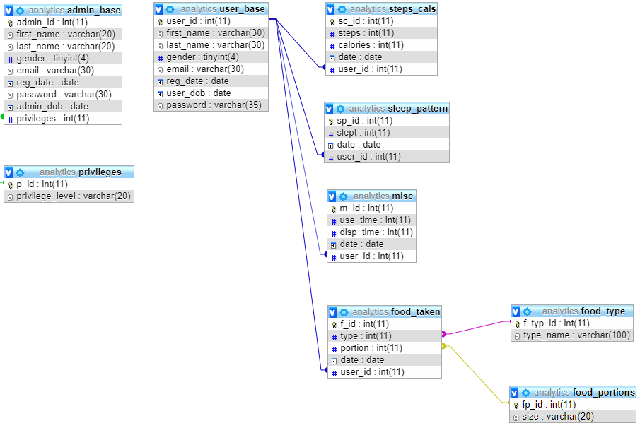

Complete Database (fig 3)

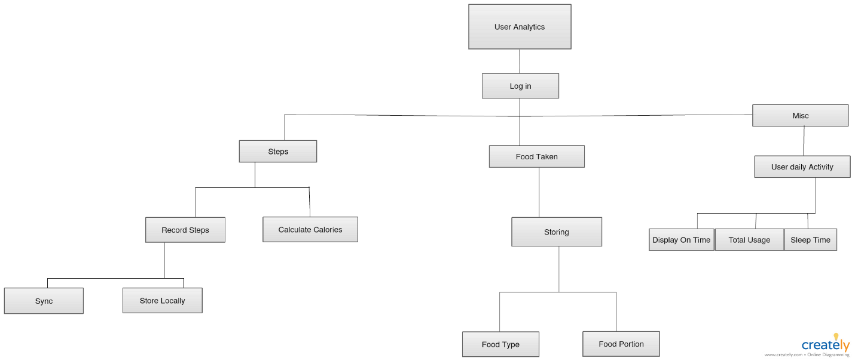

Fig. 3

**Screen Shots**

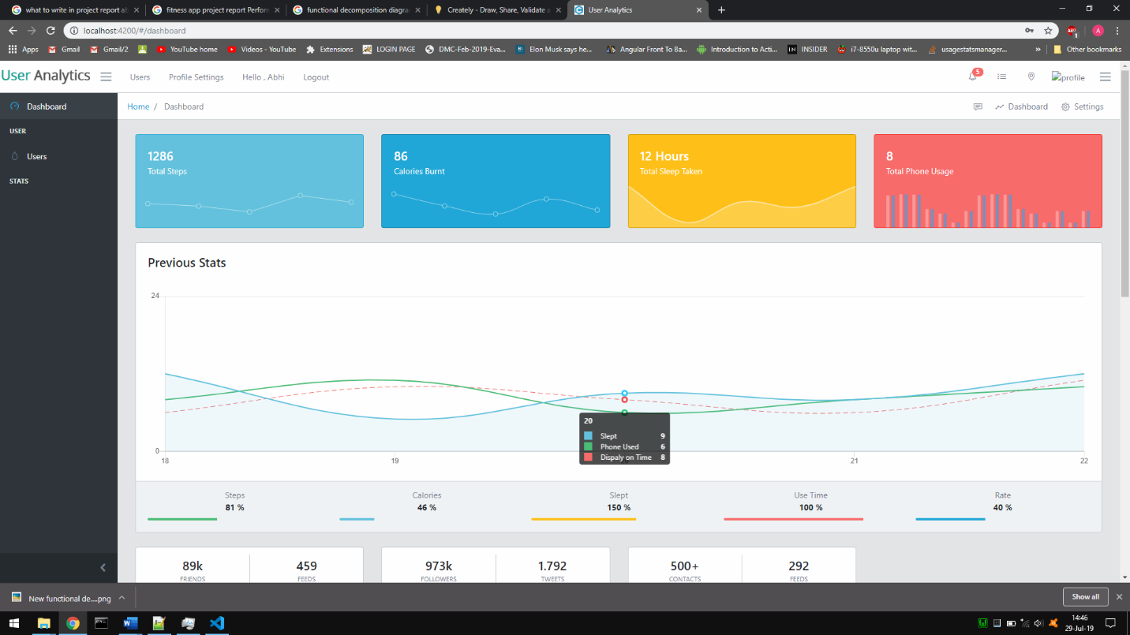

Fig. 4

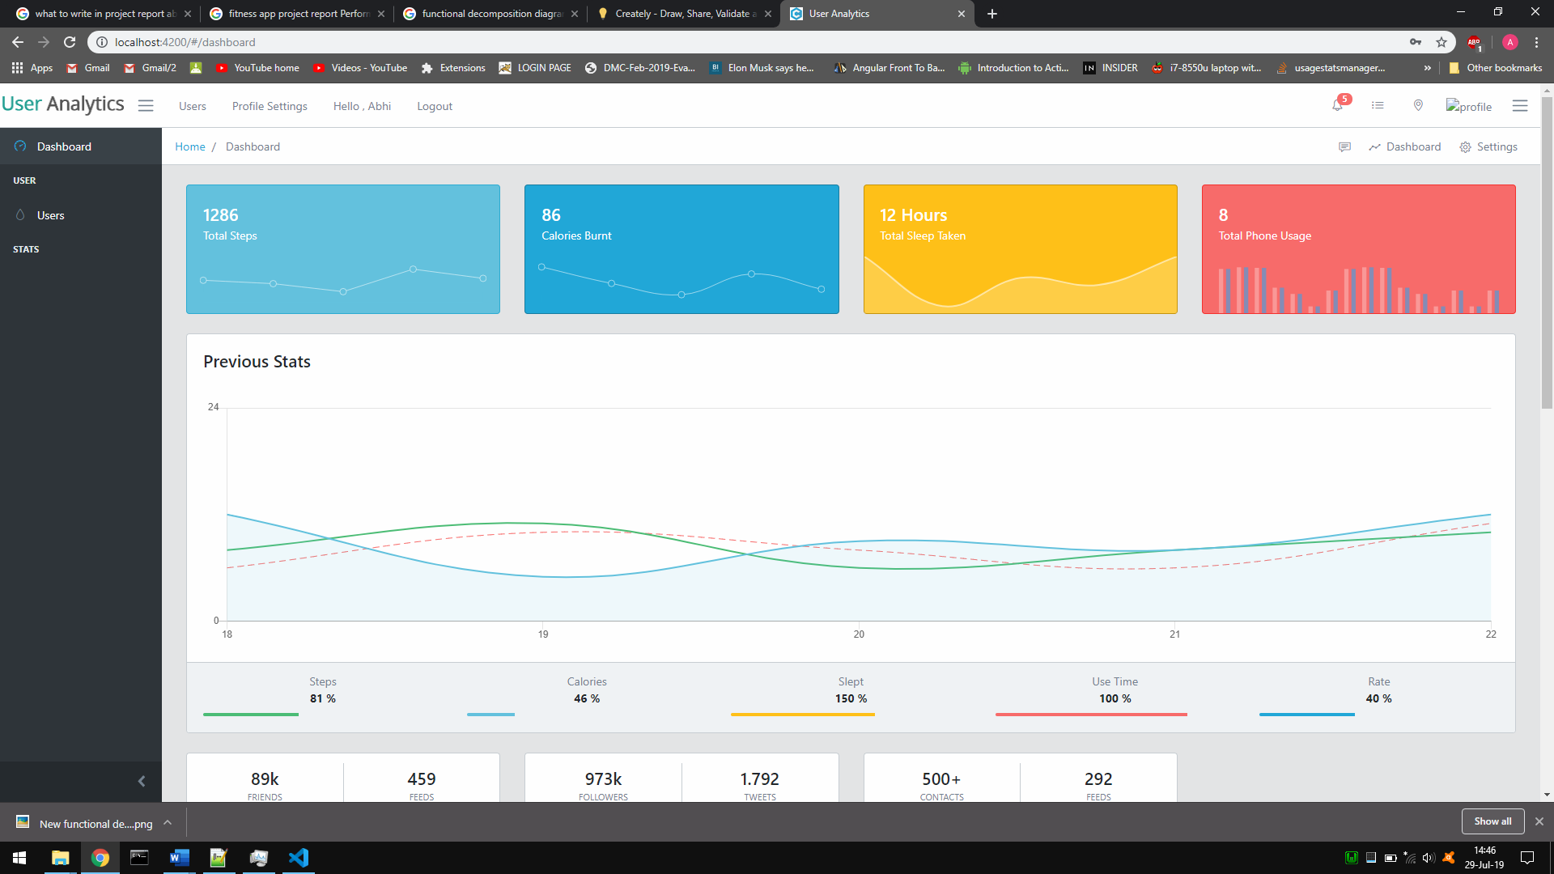

Fig. 5

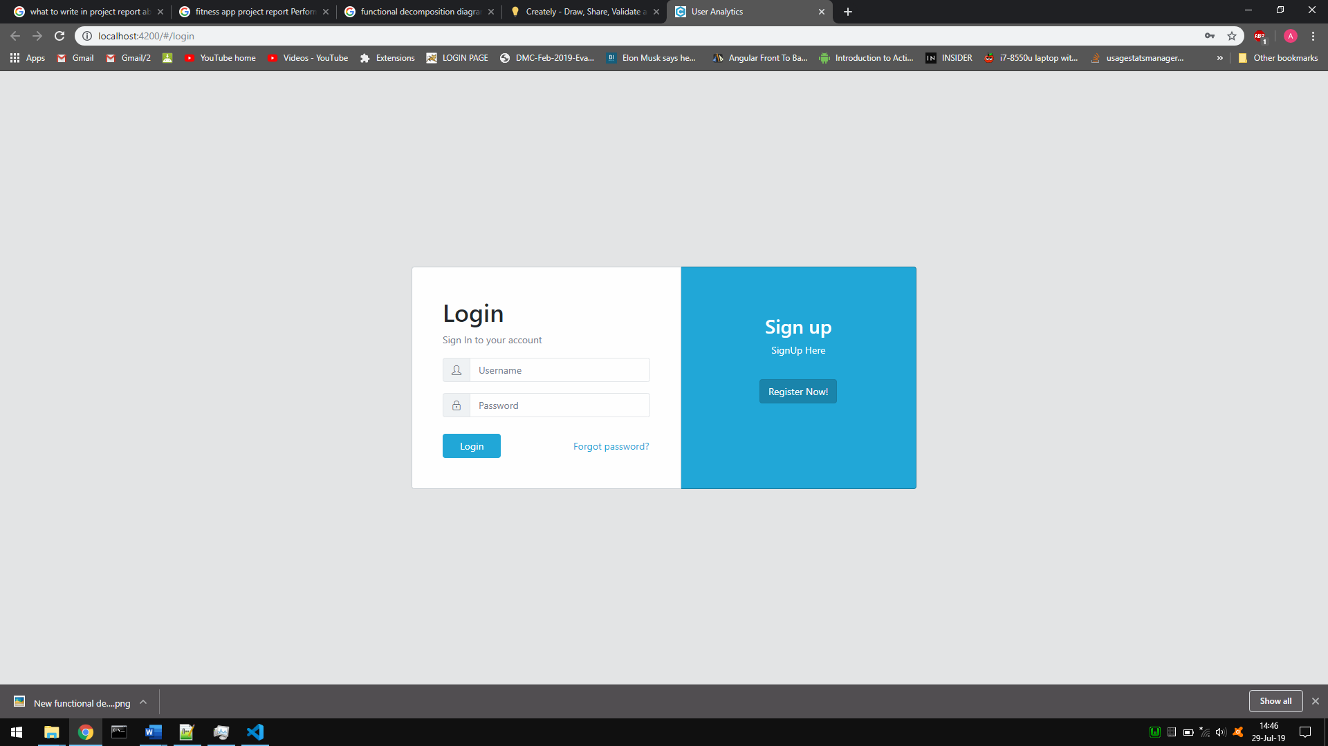

Fig. 6

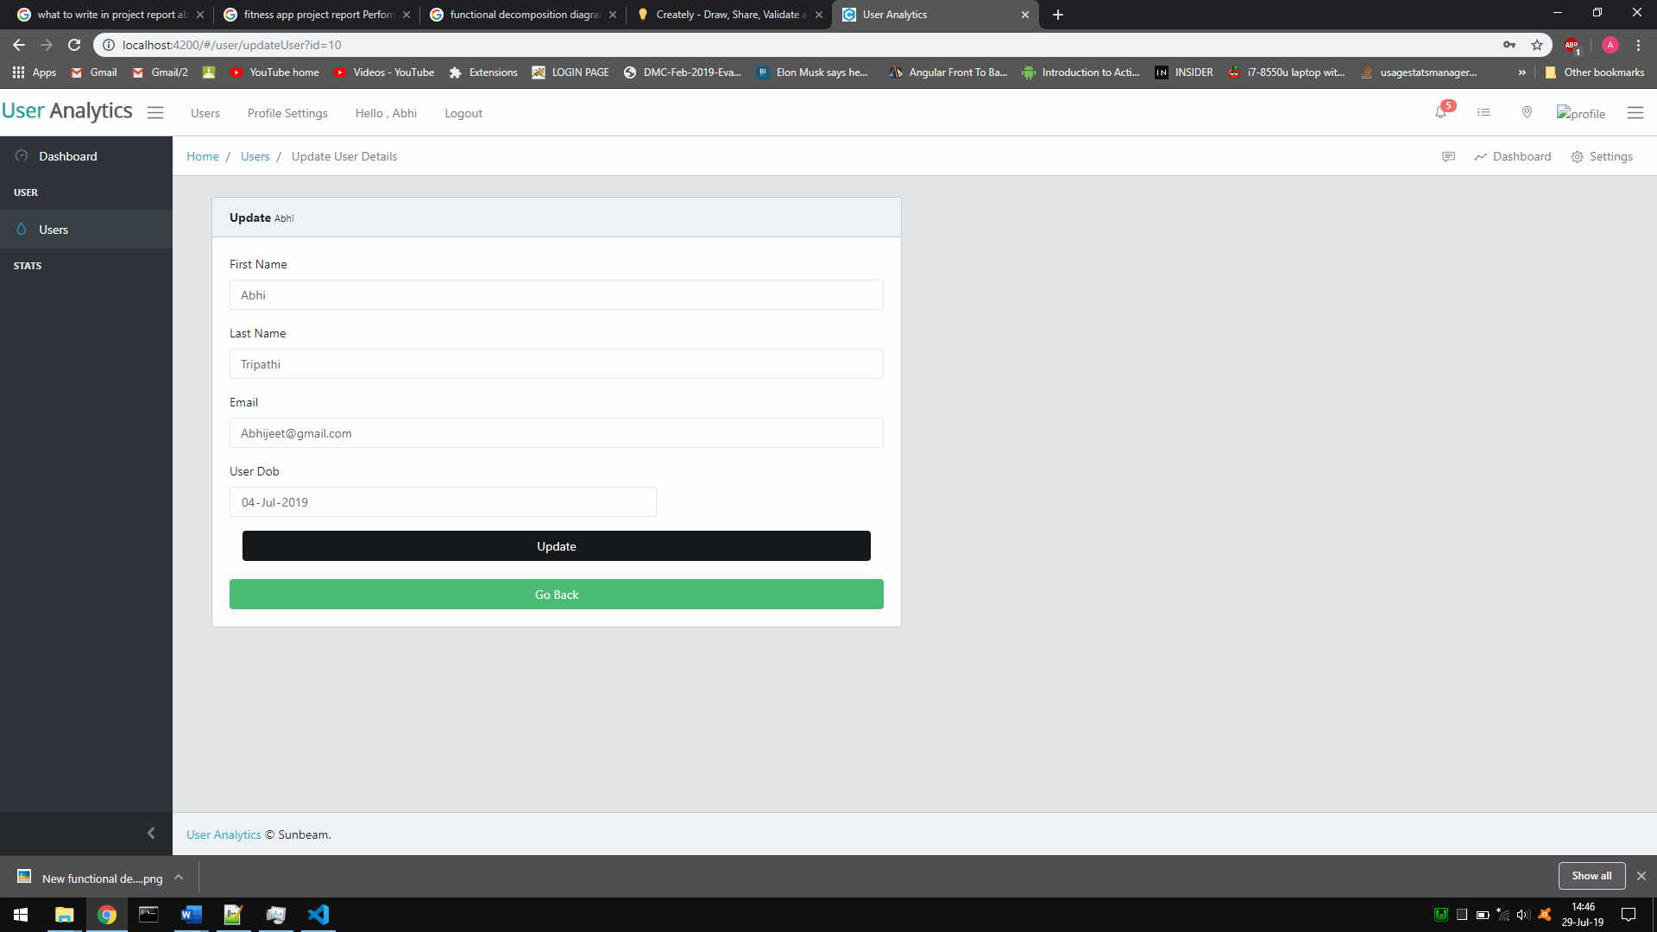

Fig. 7

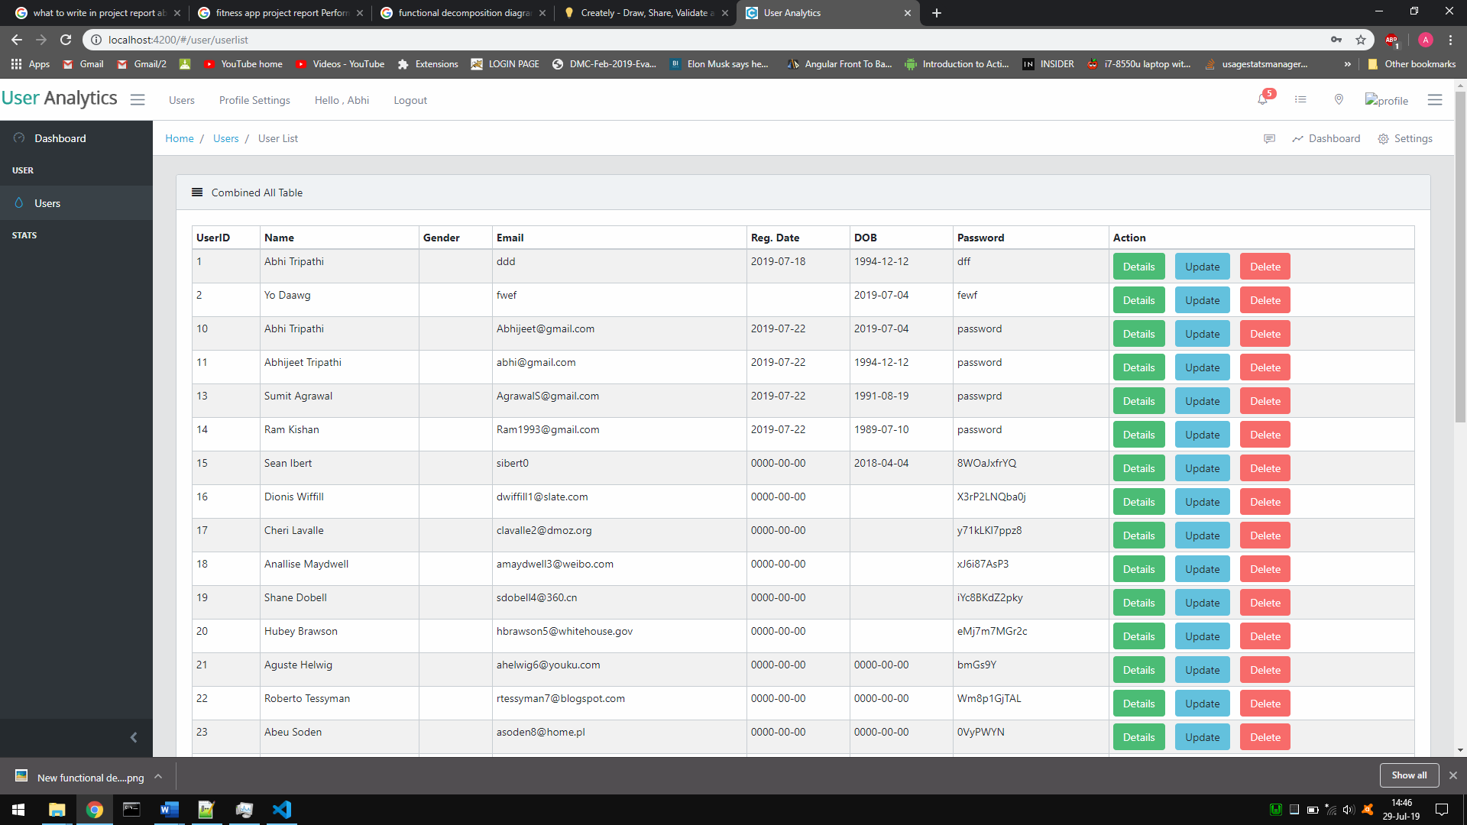

Fig. 8

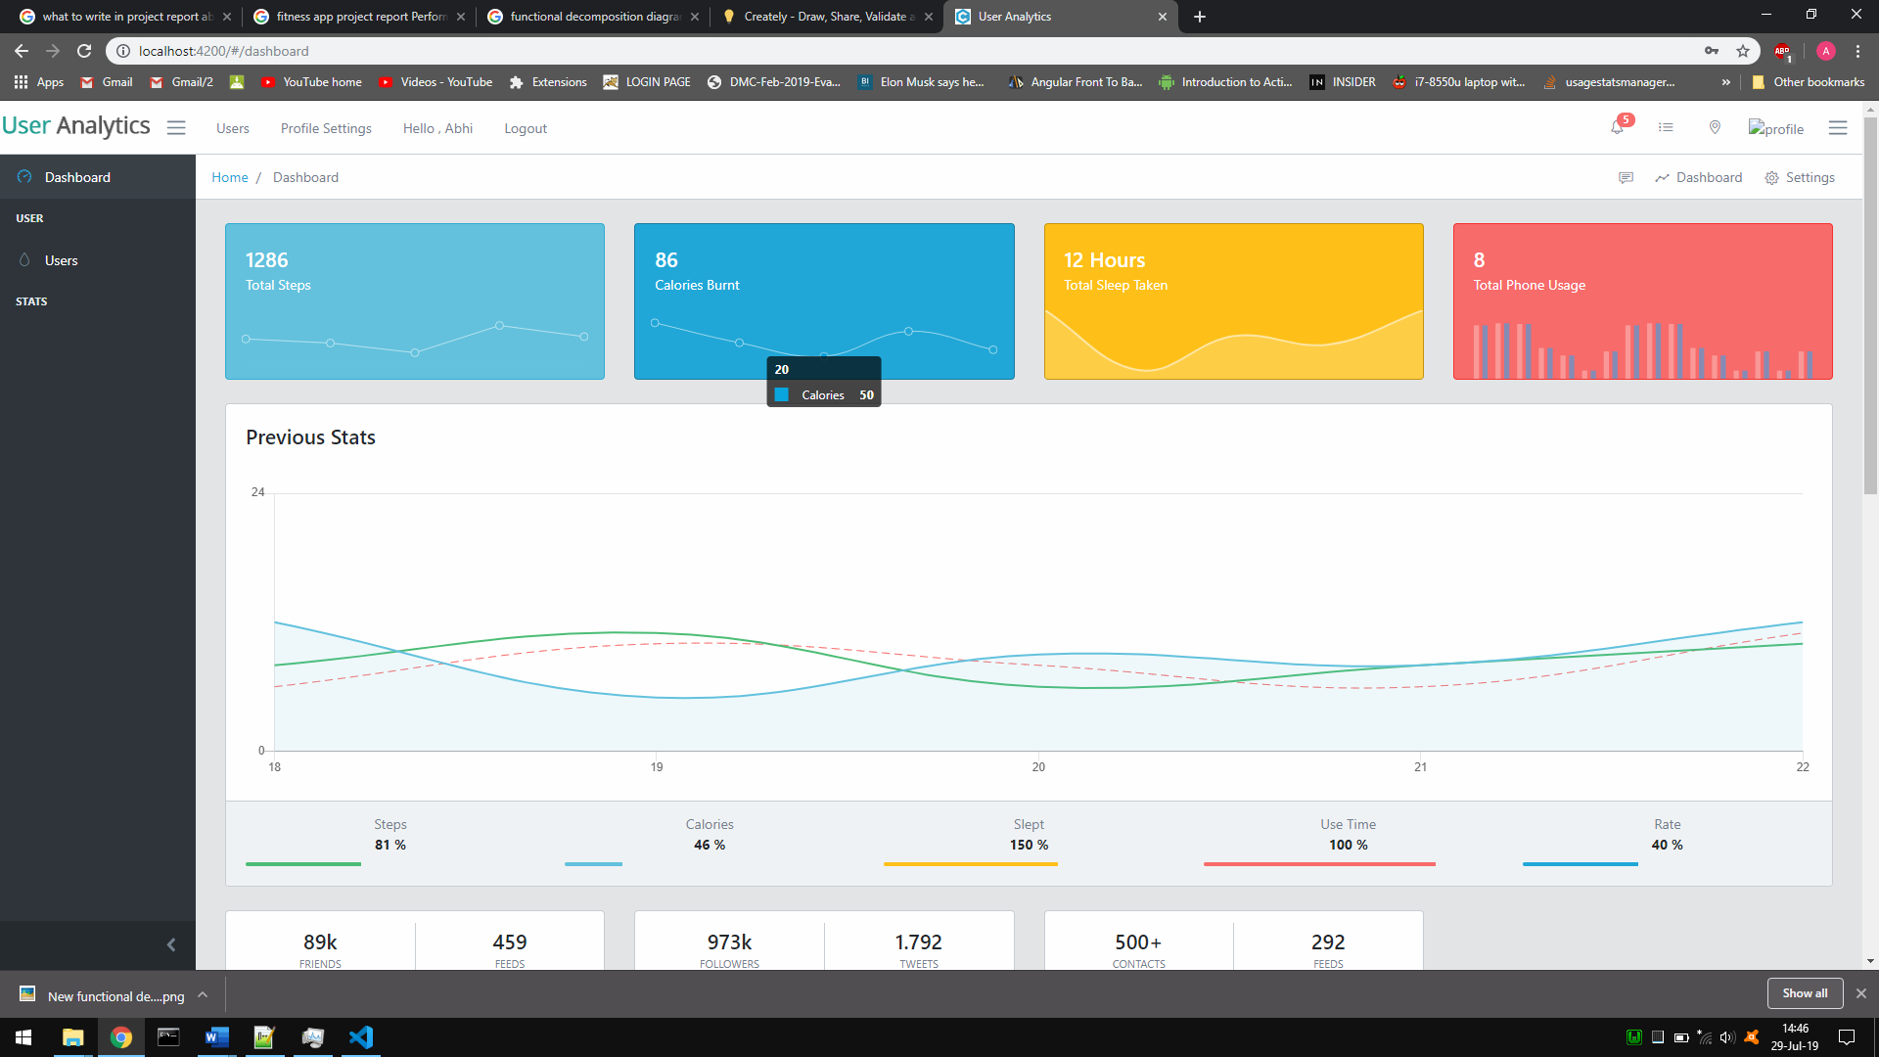

Fig. 9

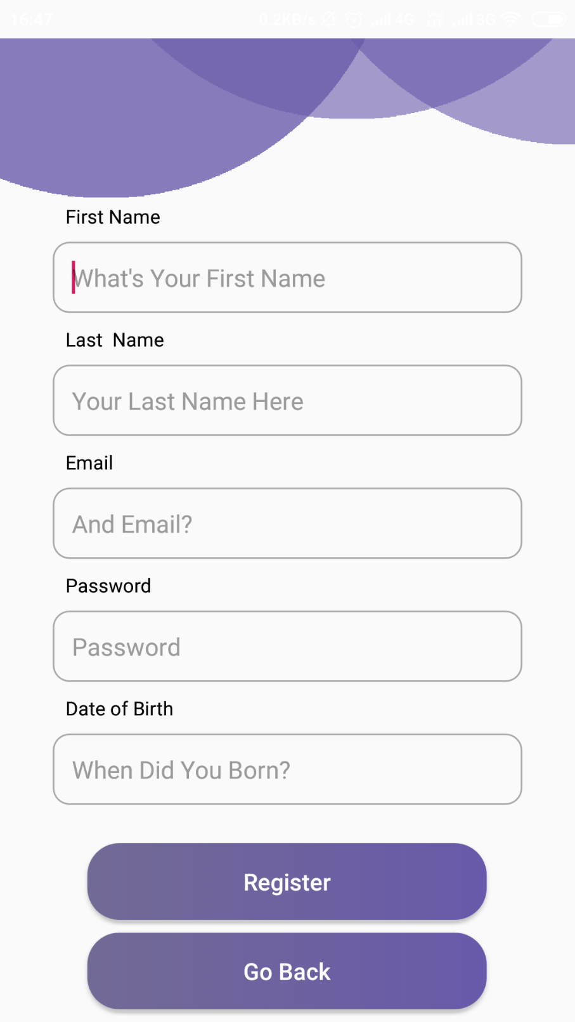

Fig. 10

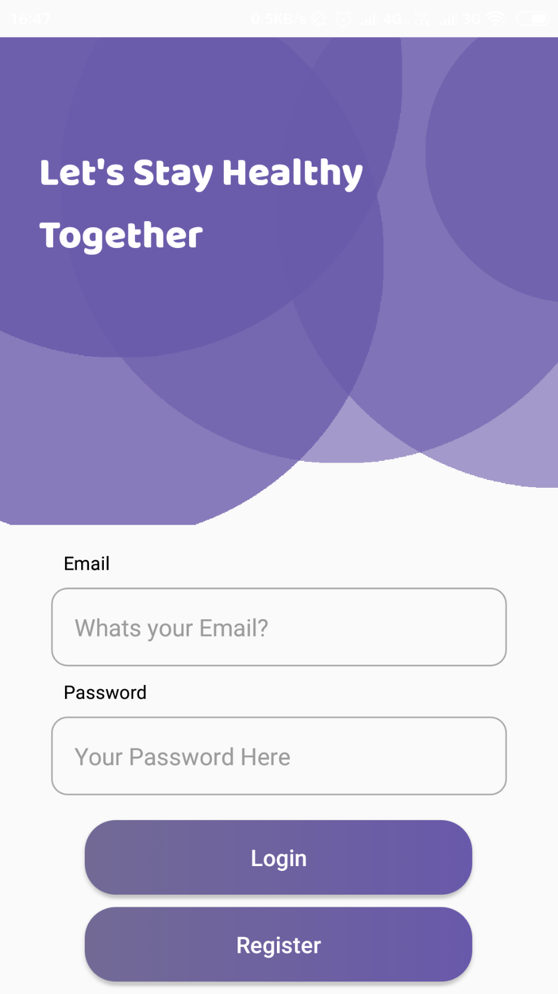

Fig. 11

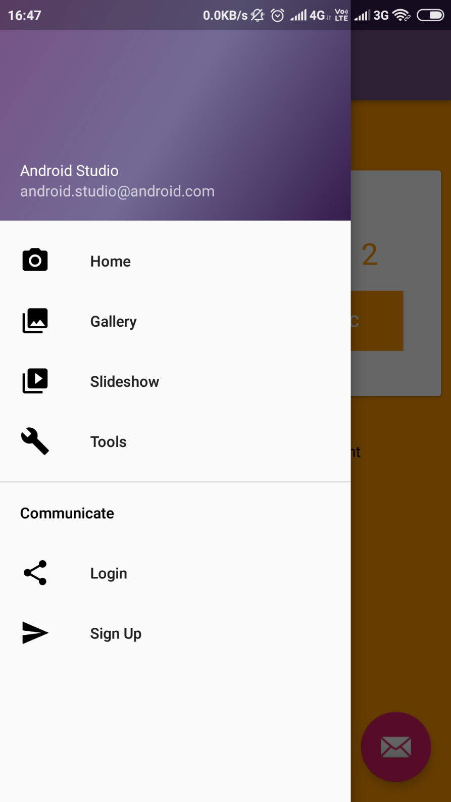

Fig. 12

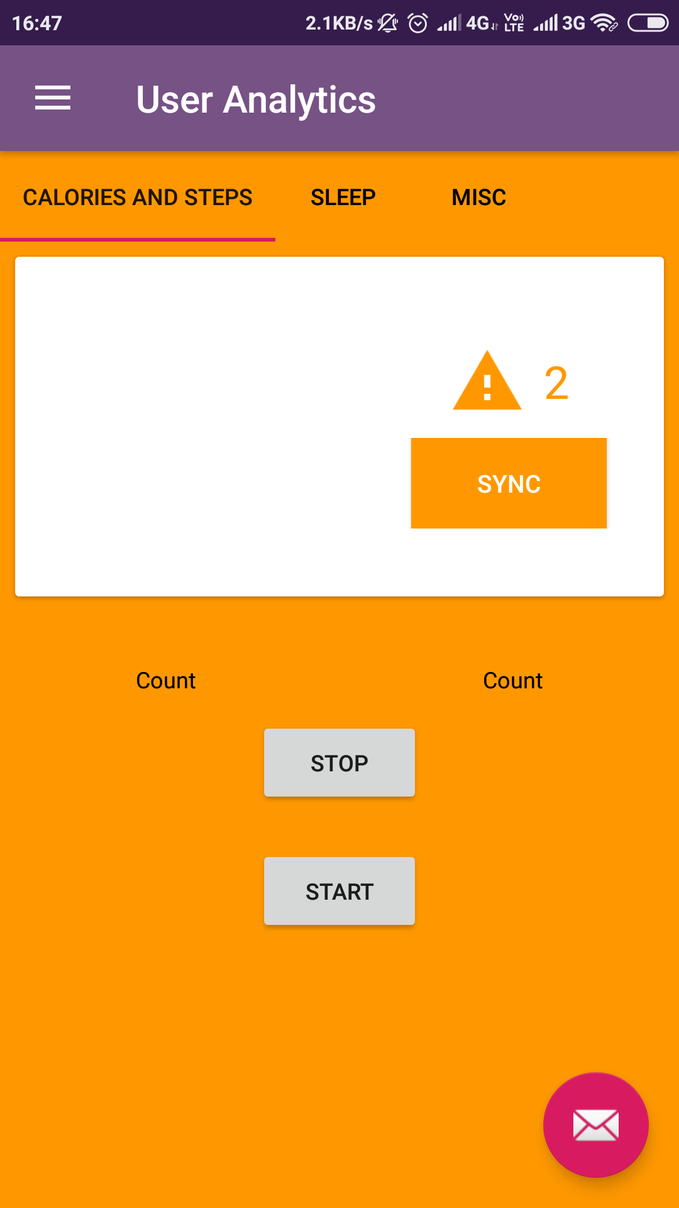

Fig. 13

**| Conclusion:**  Accomplishments While it was a challenge to develop, our project team successfully created a prototype wellness application for the Android platform capable of tracking, recording, and displaying data relevant to a user’s sleep, activity, and mood habits. While the full scope of the initial app design was not realized, all of the core data tracking functionality has been successfully implemented

**| Future Work** : While I feel that I’ve successfully implemented the desired tracking functionalities, there are still several elements that could be added to improve the effectiveness of the app. Another possible improvement is to enhance the accuracy of our tracking algorithms. While we have already devoted a significant portion of our development time to writing and testing these algorithms, theoretically, they can always be improved. The sleep tracking algorithm would likely be the most in need of improvement, due to the difficulty of analyzing sleep simply with sound and light levels. In this case, a biometric device that could track and record pulse or movement, would contribute tremendously to the accuracy of the collected sleep data.

**| References:**

Time - Alarm Clock. Retrieved from https://play.google.com/store/apps/details?id=com.azumio.android.sleeptime&feature=search_r esult#?t=W251bGwsMSwxLDEsImNvbS5henVtaW8uYW5kcm9pZC5zbGVlcHRpbWUiXQ Fitbit Inc. (n.d.). Fitbit. Retrieved from http://dev.fitbit.com/ Fragments. (n.d.). Retrieved March 23, 2015, from

http://developer.android.com/guide/components/fragments.html Gehring, J. (n.d.). Documentation. Retrieved March 27, 2015, from http://www.androidgraphview.org/documentation Google. (n.d.). E.

Automation and developer API - Sleep as Android. Retrieved from https://sites.google.com/site/sleepasandroid/doc/developer-api Lopresti, A. L., Hood, S. D., & Drummond, P. D. (2013). A review of lifestyle factors that contribute to important pathways associated with major depression: Diet, sleep, and exercise. Journal of Affective Disorders, 148, 12-27 Michaud, C. (n.d.). Pedometer Using Accelerometer Sensor. Retrieved March 26, 2015, from

http://nebomusic.net/androidlessons/Pedometer_Project.pdf PELUSO MAM et al. Physical activity and mental health: the association between exercise and mood. CLINICS 60(1): 61-70, 2005. ProtoGeo. (n.d.). Moves. Retrieved from

https://play.google.com/store/apps/details?id=com.protogeo.moves&hl=en Recording Fitness Data. (n.d.). Retrieved March 23, 2015, from https://developers.google.com/fit/android/record Sleepiness:

Cognitive and Emotional Effects. (n.d.). Retrieved March 23, 2015, from http://www.webmd.com/sleep-disorders/excessive-sleepiness-10/emotions-cognitive?page=3 Sonstroem RJ, Morgan WP. Exercise and self-esteem rationale and model. Med Sci Sports Exerc 1989;21:329-37. ViewPager. (n.d.). Retrieved March 23, 2015, from

http://developer.android.com/reference/android/support/v4/view/ViewPager.html 40 Working with

the Fitness History. (n.d.). Retrieved March 23, 2015, from https://developers.google.com/fit/android/history Build software better, together. (n.d.). Retrieved

December 15, 2014, from https://github.com/ Tudor-Locke, C., & Bassett Jr, D. (n.d.). How Many Steps/Day Are Enough? Retrieved November 15, 2014, from

http://www.health.utah.edu/peak/docs/Tudor Locke Paper.pdf National Sleep Foundation

Recommends New Sleep Times. (n.d.). Retrieved February 27, 2015, from http://sleepfoundation.org/media-center/press-release/national-sleep-foundationrecommends-new-sleep-times